BAGTASTIC

WIREFRAME

|  |  |  |
| --- | --- | --- |
| **Supervisor.** | **SIR SHEHRYAR** | |
| **Batch.** | **2207G2** | |
| **Group.** | A | |
| **Serial No.** | **Enrollment Number** | **Student Name** |
| 1. | Student1388784 | ZARYAB AHMED KHAN NIAZI, |
| 2. | Student1397261 | SYED QAISER ALAM, |
| 3. | Student1397281 | WAJEEH ABDUL REHMAN, |
| 4. | Student1395050 | NASAR KHAN |

**ACKNOWLEDGEMENT**

Before anything, I would like to thanks my beloved teacher who helped us a lot in reviewing this project within the limited time frame.

Secondly, we would also like to thank the eProject team at Aptech Head Office, who gave us the golden opportunity to do this wonderful project about Nexus Aquarium

Thirdly, we also thank the eProject team, some of the benefits are as under: Re-enforcement of skills happens in the experiential learning process. ∙ A mentor, ensuring that we do not get drifted, constantly guides us. ∙ It gives us a lot of confidence to face an interview as we have worked on a project. We can explain virtually everything on the subject we have le

***SYNOPSIS***

With the help of technology, we are providing people ease to buy utensils and know our Utensils. We are providing relaxing survey to our website. Attached all the information about the Utensils. So shares the perfect relaxing images through the website for everyone to know. For the convenience of the people we have provided map for the route. Best utensils website to visit.

***PROBLEM DEFINITION***

The bagista is the famous ONLINE shop which consists of varieties. It has various shops located at different location. To advertise about the quality, types and to reach remote masses the shop owner wants to create a website.

***CUSTOMER REQUIREMENT***

***SPECIFICATION (CRS)***

The Web site is to be created based on the following requirements.

1. Home page should give some description about the utensils stores and also when it came into existence.
2. Also different section of the type of utensils likes which quality and their respective rates must be enlisted.
3. Specification of the utensils must be added.
4. Also the day in which the discount of how much percent is offered.
5. About Us
6. Contact Us: location of different counters.
7. Comparison page (must allowed the same product of different type to be compared.
8. Feedback: feed on the quality and services can be added.

***SCOPE OF THE WORK (IN BRIEF)***

The website is to be developed for the Windows Platform using HTML5,    JavaScript and bootstrap jQuery. The site should work well in all leading browsers including Chrome, Firefox etc. Our welcome page icon is re-directed to the main web page Ever essential content direct to relative content.

WIREFRAME

NAVBAR

CORSEL

NAVBAR

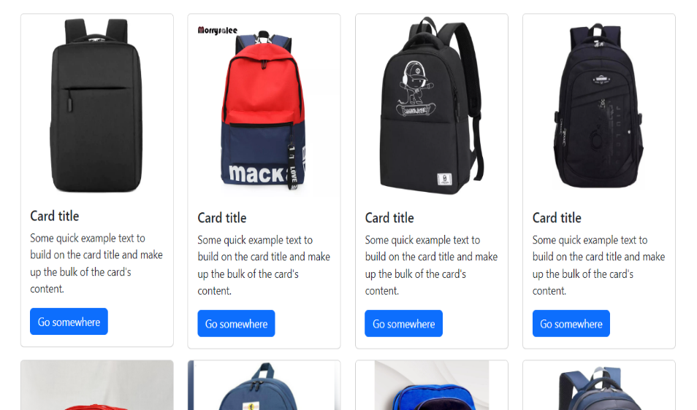

BOYS-PRODUCT

NAVBAR

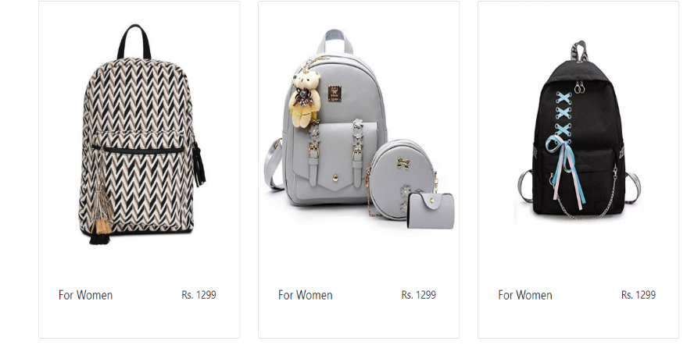

GIRLS-PRODUCT

NAVBAR

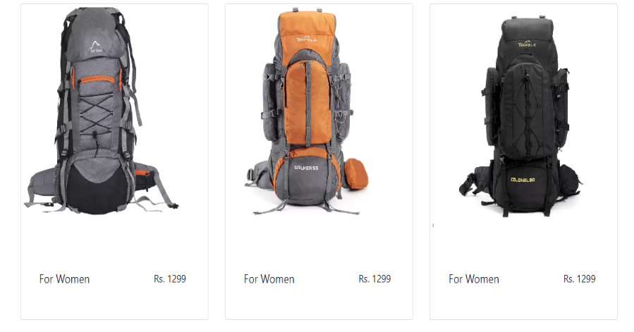

BAGPACK-PRODUCT

NAVBAR

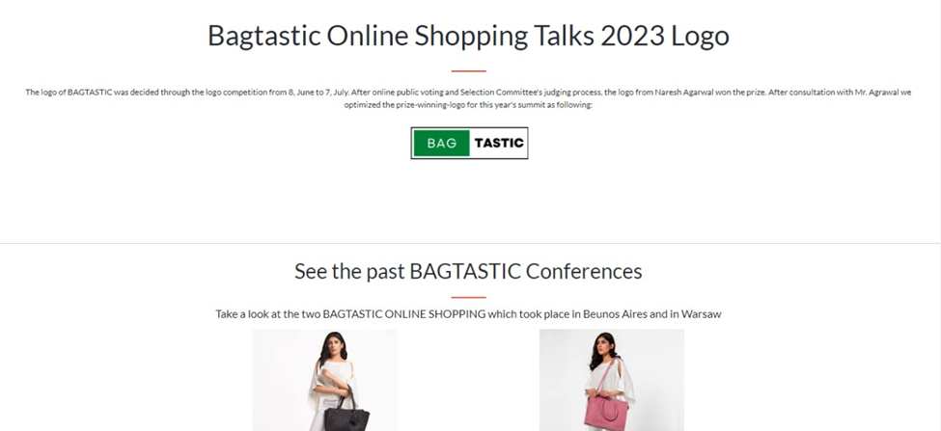

ABOUT

NAVBAR

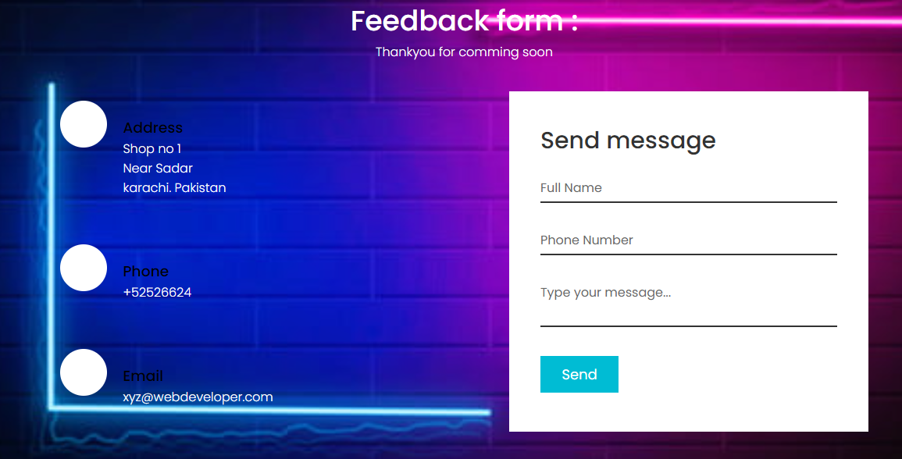

FEEDBACK

NAVBAR

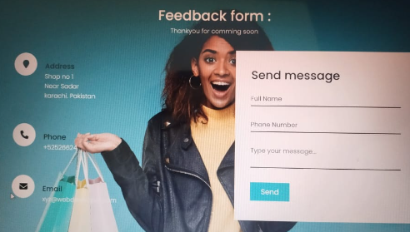

CONTACT-US

NAVBAR

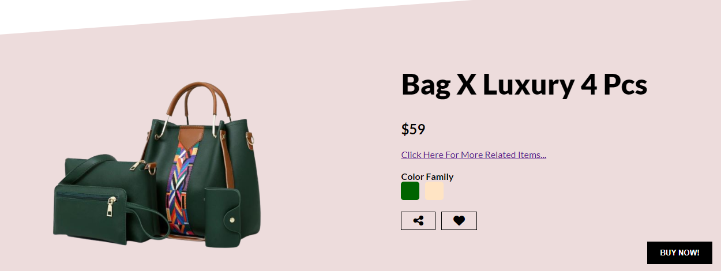

GALLERY

SECTION

NAVBAR



NEW SEASON

NAVBAR

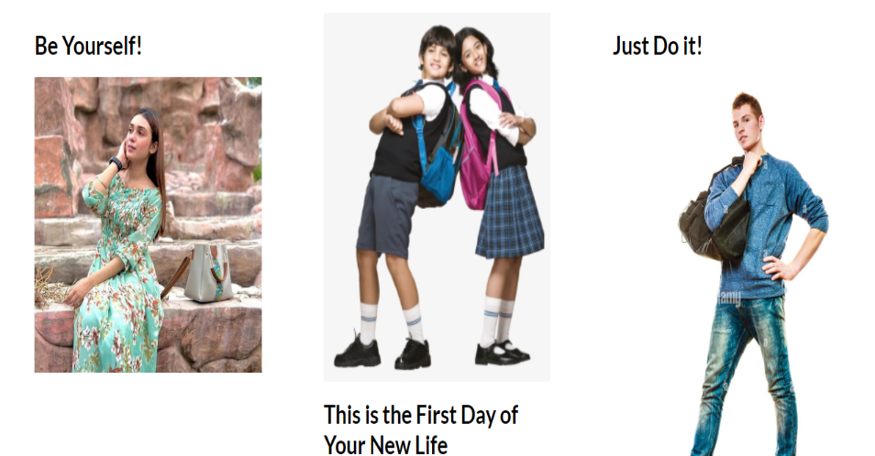

GALLERY

SECTION

NAVBAR

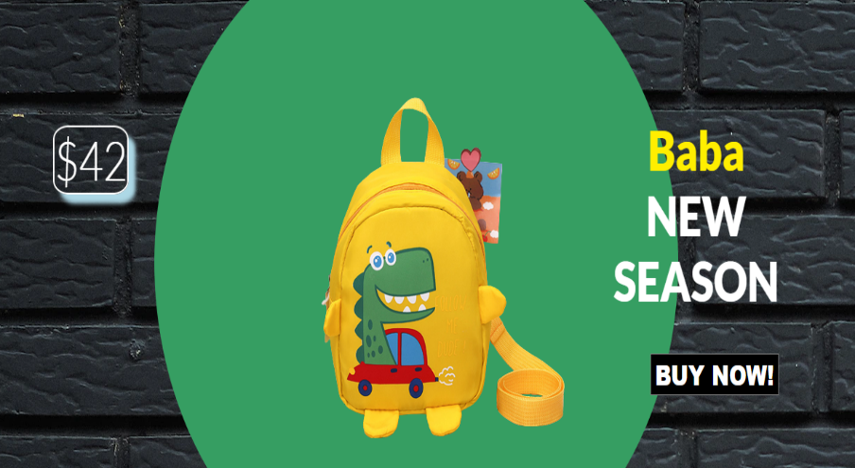

CORSEL

NAVBAR

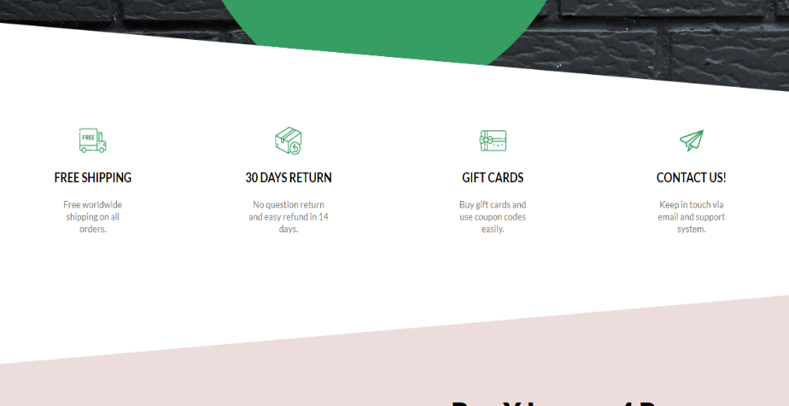

CARD-ITEM

NAVBAR

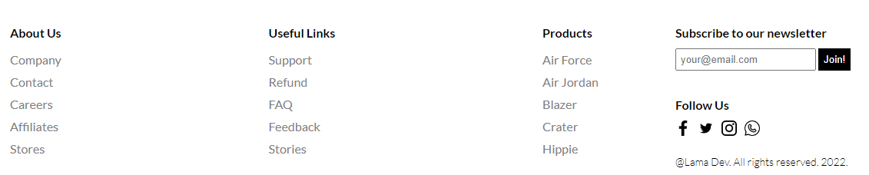

ABOUT

***TASK SHEET REVIEW 2***

|  |  |  |  |  |  |  |
| --- | --- | --- | --- | --- | --- | --- |
| Project Ref. No.:  eP/Advertisement Portal Management System/01 | | Project  title | Date of Preparation of Activity Plan | | | |
| No | Task | bagtastic | Actual | Actual | Team-mate | Status |
| Start Date | Days | wajeeh |
| 1 | Build Home, Visit Page | 15/nov/22 | 5 | wajeeh | Complete |
| 2 | Build About page | 20/nov/22 | 3 | Qaiser | Complete |
| 3 | Build Contact us | 22/nov/22 | 3 | Qaiser | Complete |
| 4 | Build Categories pages | 25/dec/22 | 10 | nasar | Complete |
| 5 | Build Comparison | 2/dec22 | 4 | nasar | Complete |
| 6 | Build  Login page  Signup page | 3/Nov/22 | 3 | Zaryab | Complete |
| 7 | Begin Code  JavaScript for Home page and About page | 7/Nov/22 | 3 | wajeeh | Complete |
| 8 | Begin Code  Support For  Browsers and content | 9/nov/22 | 4 | wajeeh  Qaiser  nasar | Complete |
| 9 | Check Progress and Assign New Tasks | Every Alternative Day | - | wajeeh  Qaiser  nasar | Complete |